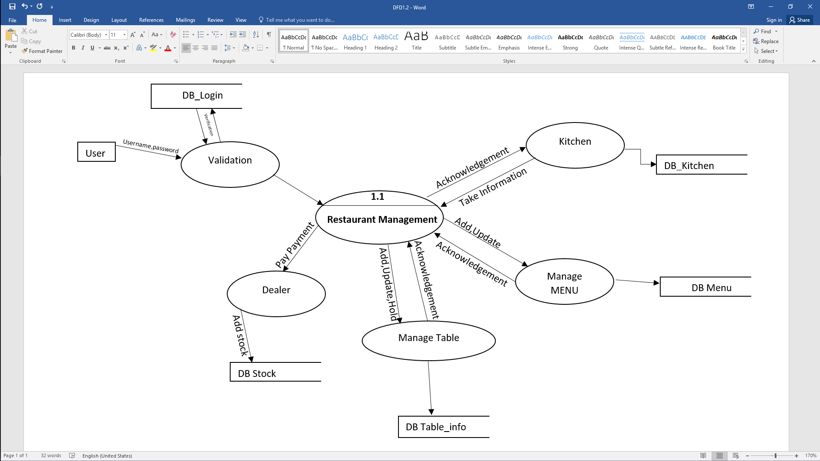

Verification

DB_Login

Username Password

DB_Kitchen

User

DB Menu

**1.1**

Acknowledgement

Add,Update,Hold

Acknowledgement

DB Table_info

Acknowledgement

Add stock

Pay Payment

DB Stock

**Restaurant Management**